Login: Username/Password: [shiv.pal@capgemini.com](mailto:shiv.pal@capgemini.com)/happy193

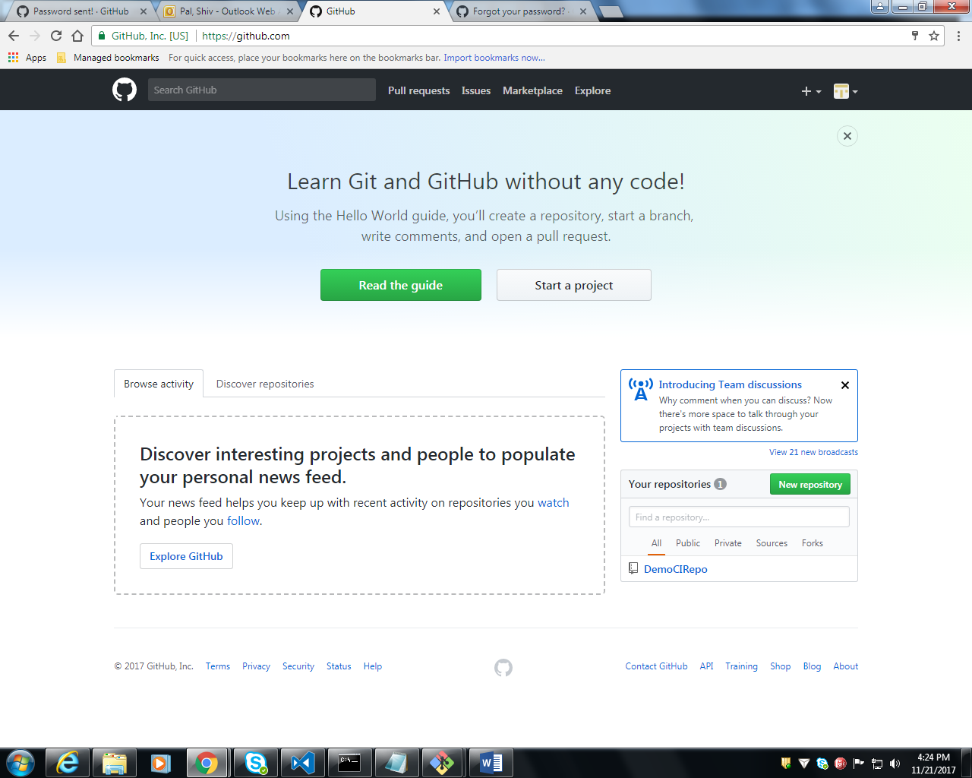

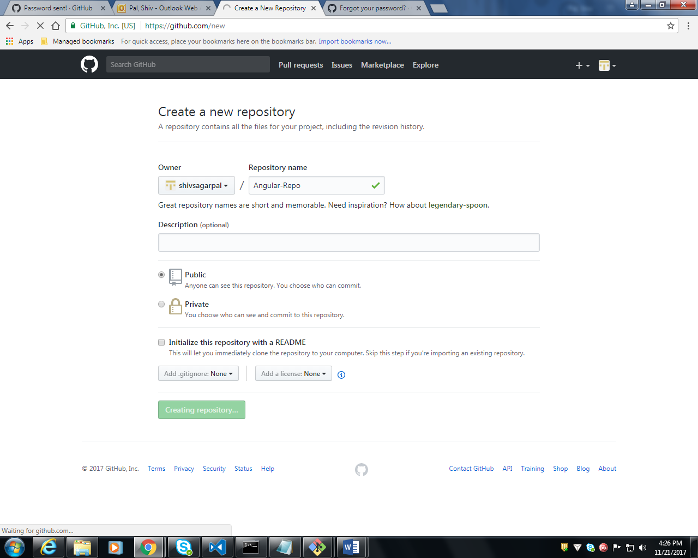

Copy: git remote add origin <https://github.com/shivsagarpal/Angular-Repo.git>

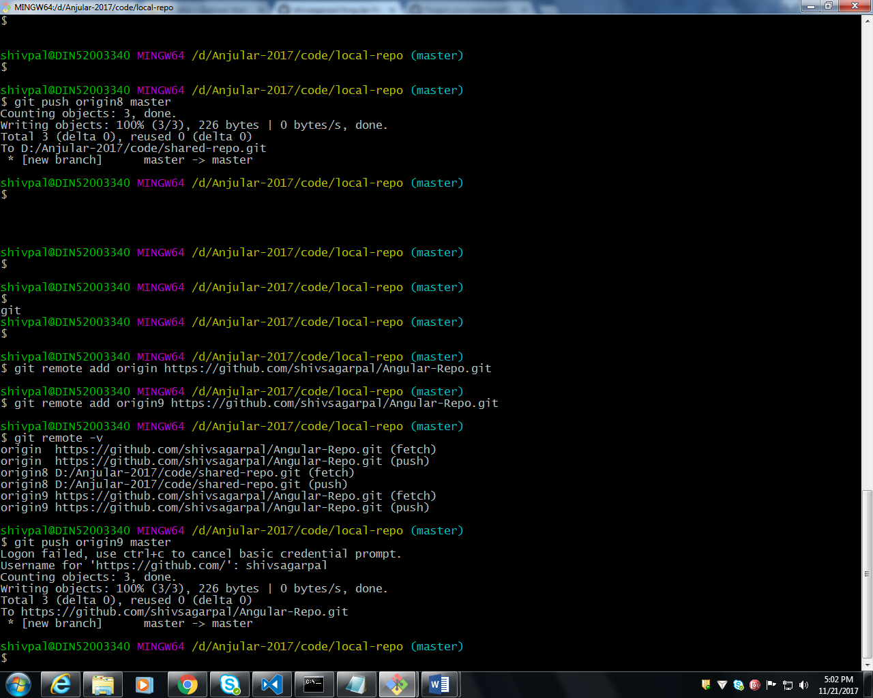

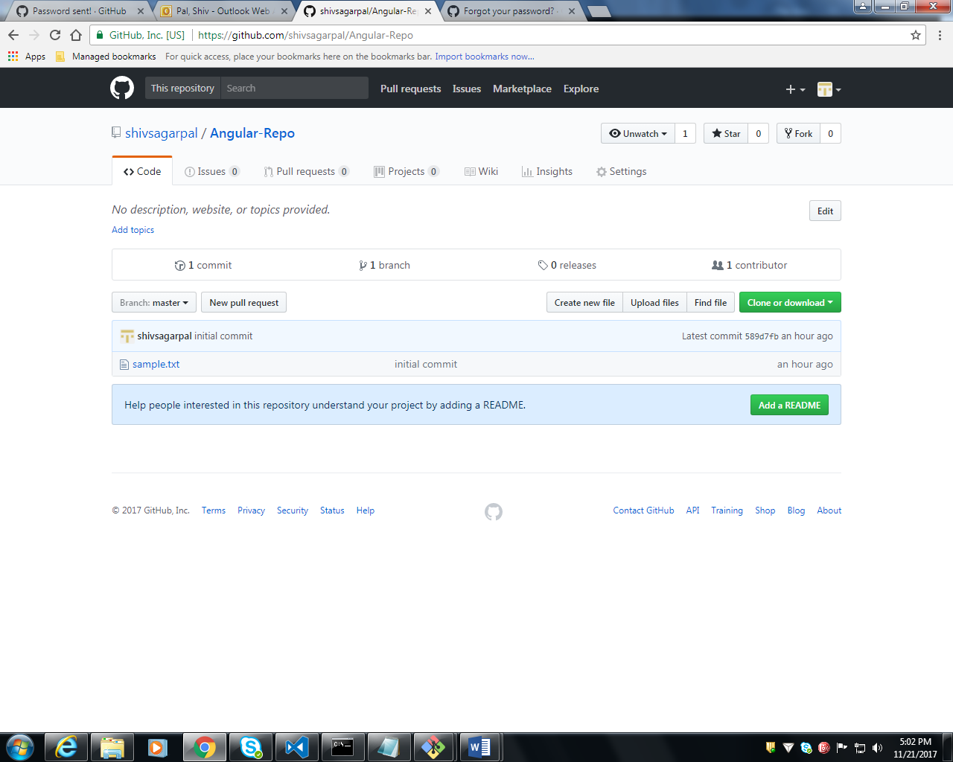

<https://github.com/angular>

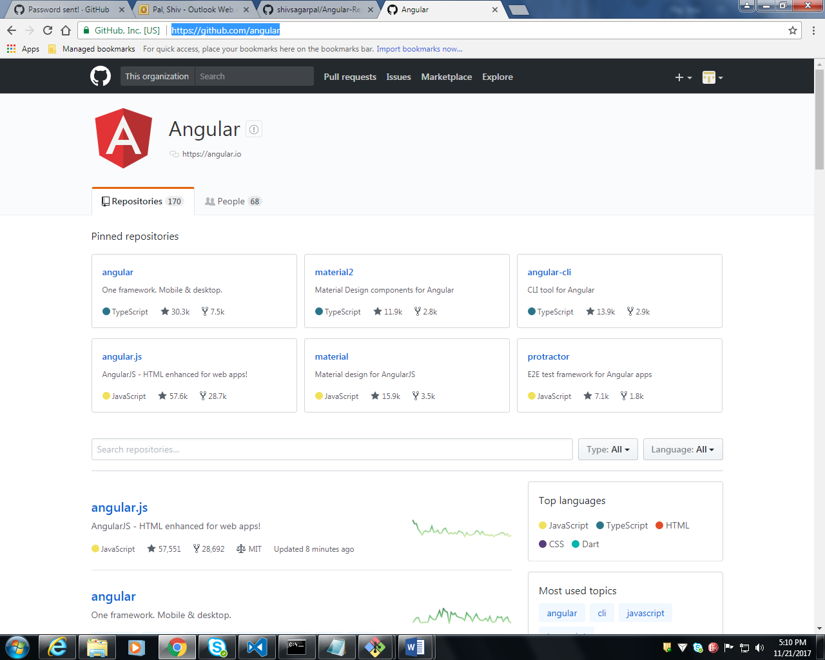

<https://github.com/angular/quickstart>

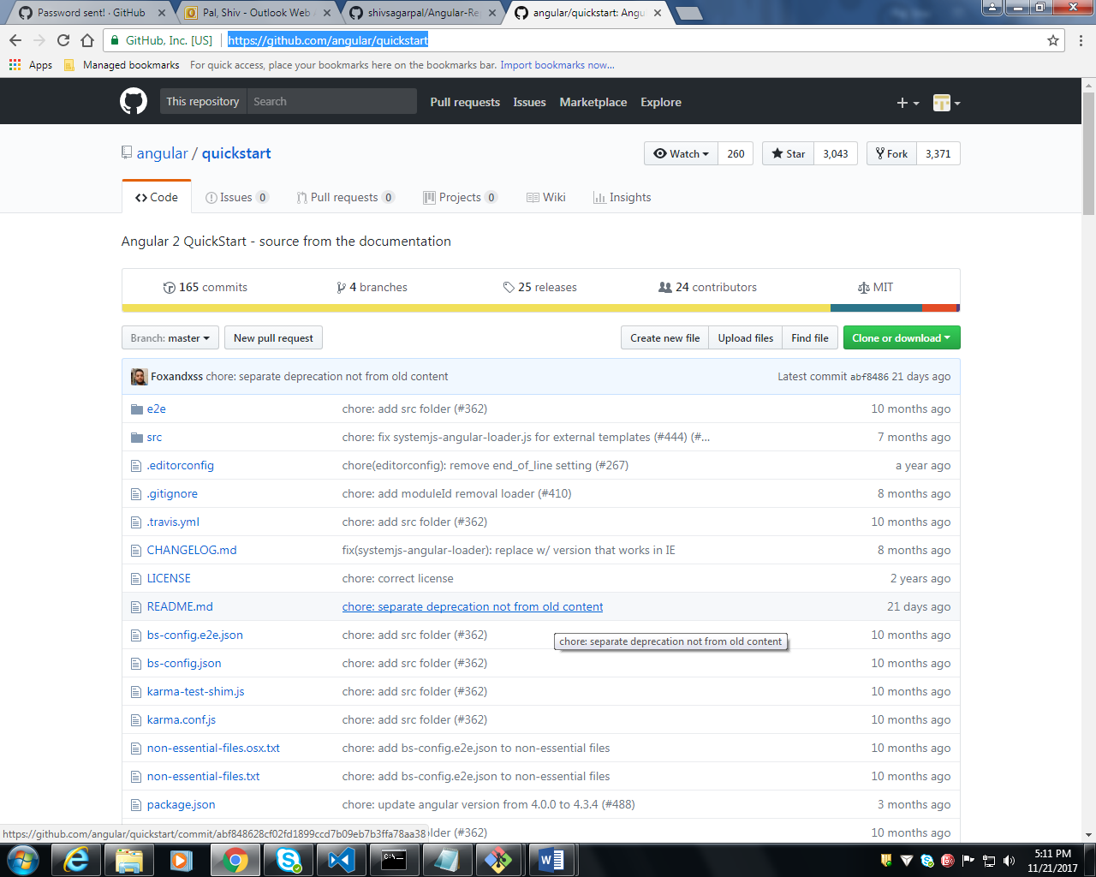

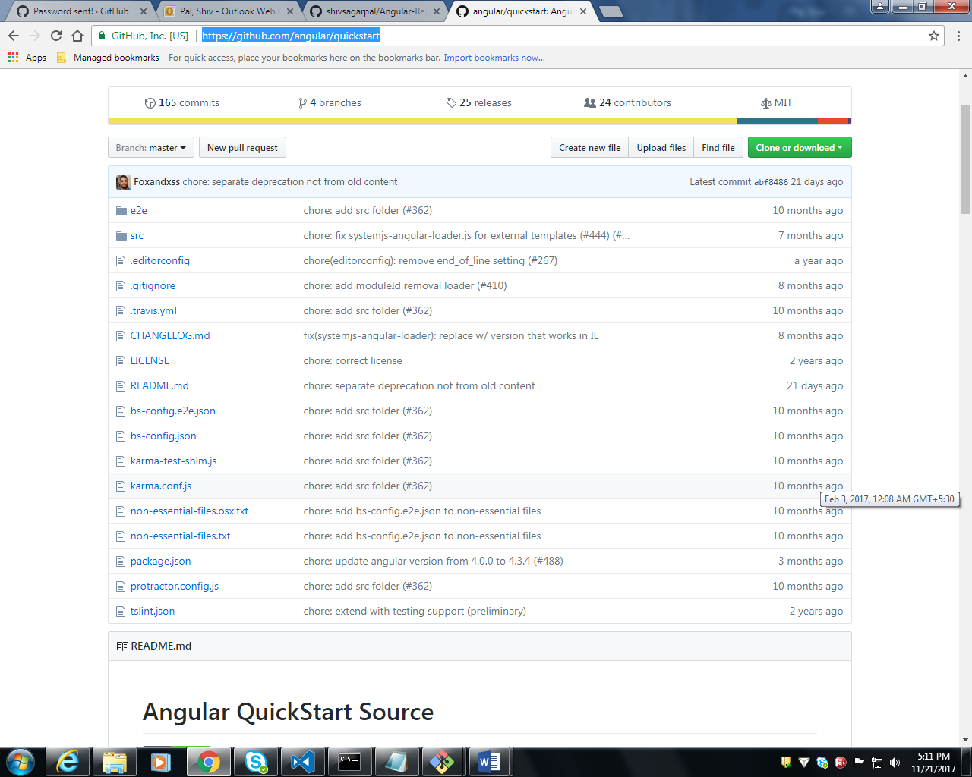

<https://github.com/angular/quickstart/tree/master/src/app>

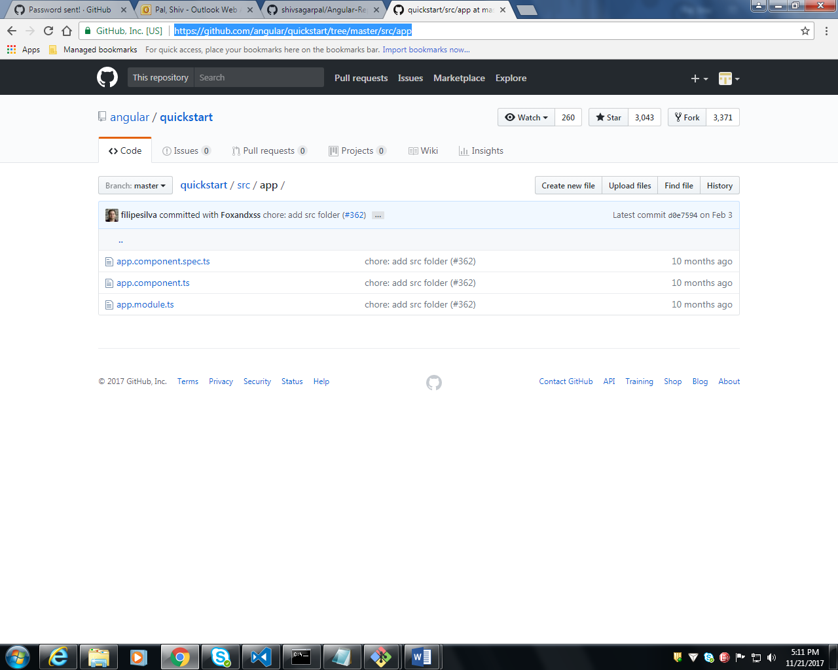

<https://github.com/jmcooper>

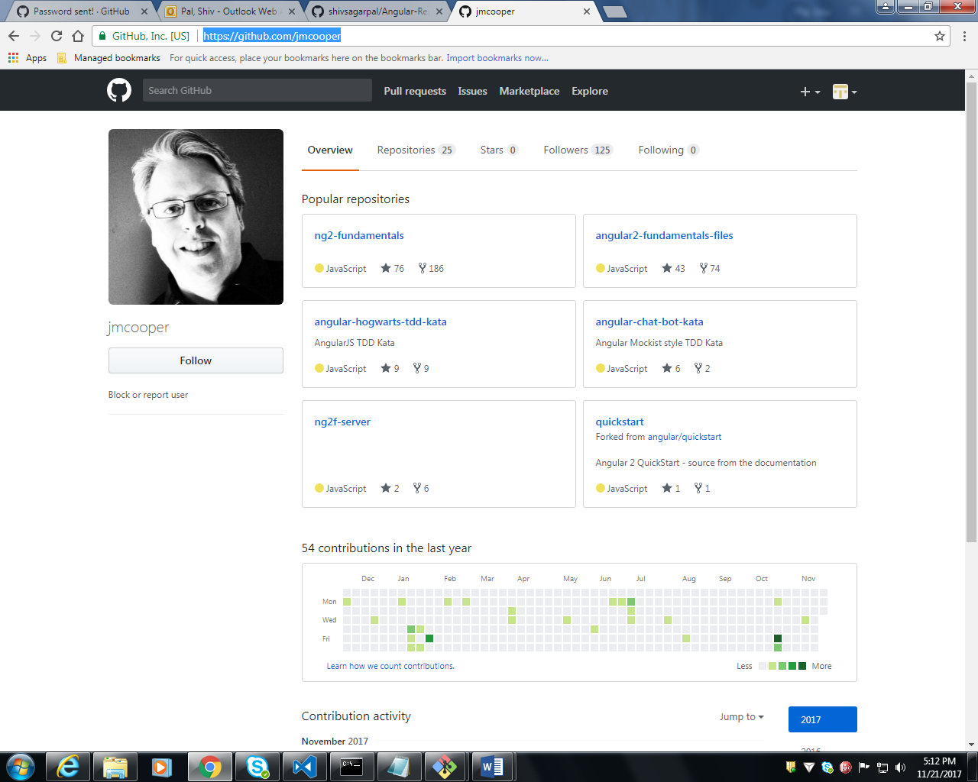

**Start 1St Angular 2 Application Steps:-**

<https://github.com/jmcooper/ng2-fundamentals>

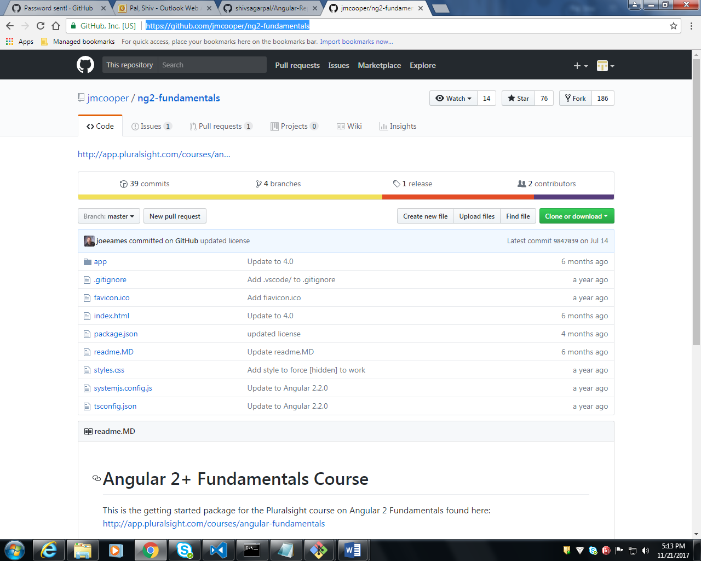

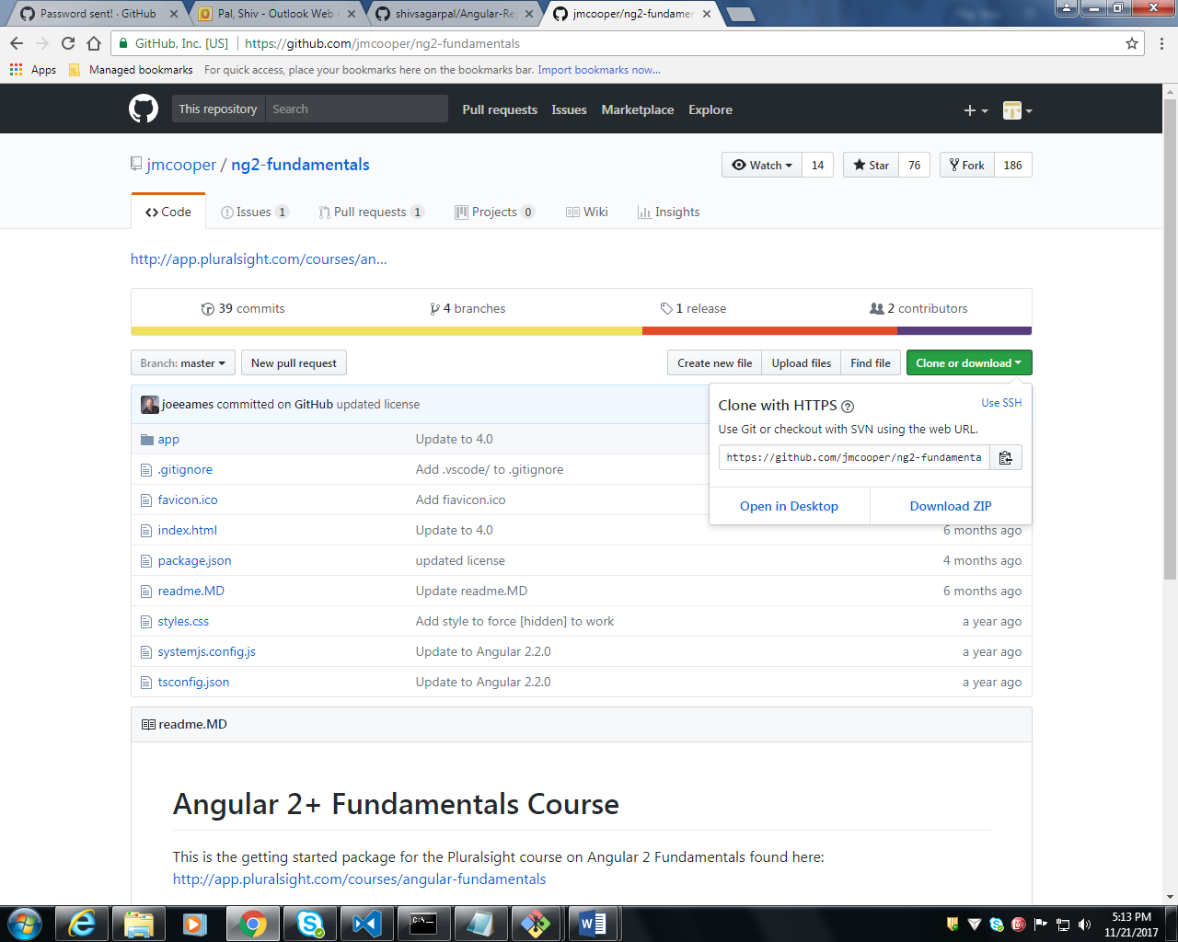

**Git Bash**

shivpal@DIN52003340 MINGW64 /d/Anjular-2017/code

$ git clone <https://github.com/jmcooper/ng2-fundamentals.git>

shivpal@DIN52003340 MINGW64 /d/Anjular-2017/code

$ git clone https://github.com/jmcooper/ng2-fundamentals.git

Cloning into 'ng2-fundamentals'...

remote: Counting objects: 567, done.

remote: Total 567 (delta 0), reused 0 (delta 0), pack-reused 567Receiving objects: 82% (465/567), 188.01 KiB | 334.00 KiB/s

Receiving objects: 100% (567/567), 191.80 KiB | 334.00 KiB/s, done.

Resolving deltas: 100% (315/315), done.

Checking connectivity... done.

GIT BASH SCREEN

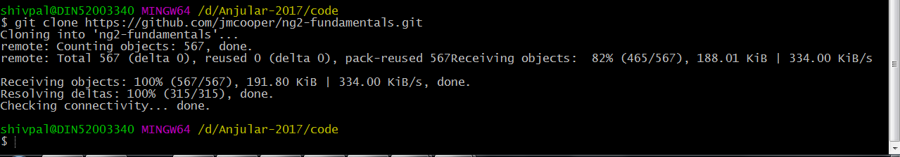

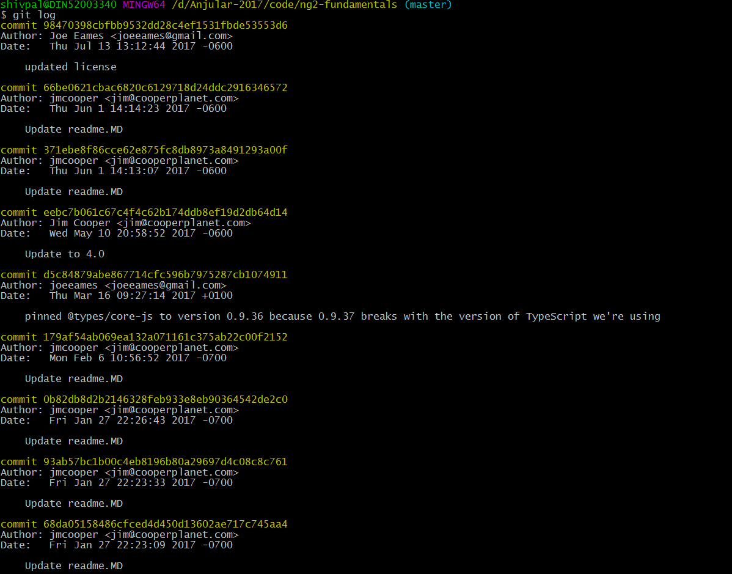

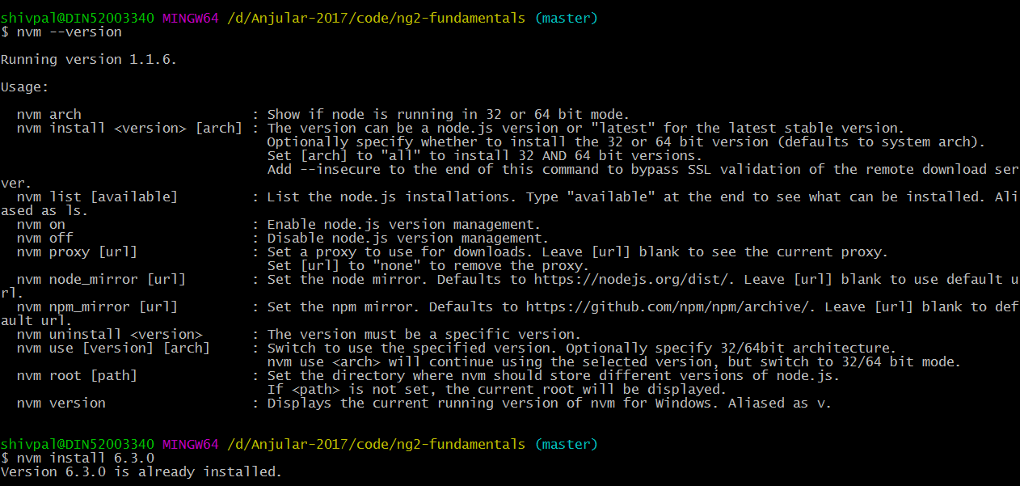

shivpal@DIN52003340 MINGW64 /d/Anjular-2017/code/ng2-fundamentals (master)

$ nvm use 6.3.0

Now using node v6.3.0 (64-bit)

shivpal@DIN52003340 MINGW64 /d/Anjular-2017/code/ng2-fundamentals (master)

$ npm --version

3.10.3

shivpal@DIN52003340 MINGW64 /d/Anjular-2017/code/ng2-fundamentals (master)

$ npm install -g typescript

C:\Program Files\nodejs\tsserver -> C:\Program Files\nodejs\node_modules\typescript\bin\tsserver

C:\Program Files\nodejs\tsc -> C:\Program Files\nodejs\node_modules\typescript\bin\tsc

C:\Program Files\nodejs

`-- typescript@2.6.1

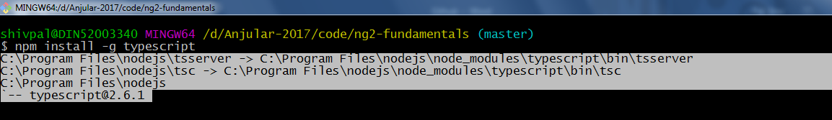

shivpal@DIN52003340 MINGW64 /d/Anjular-2017/code/ng2-fundamentals (master)

$ code .

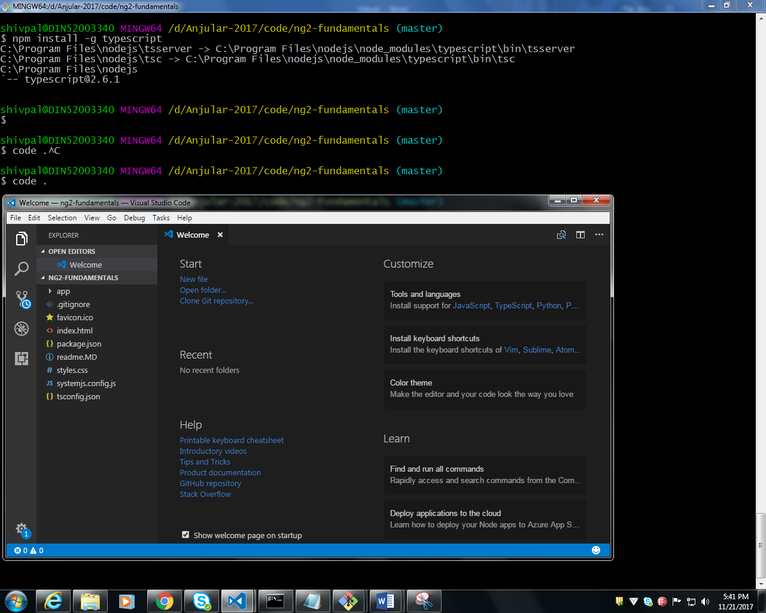

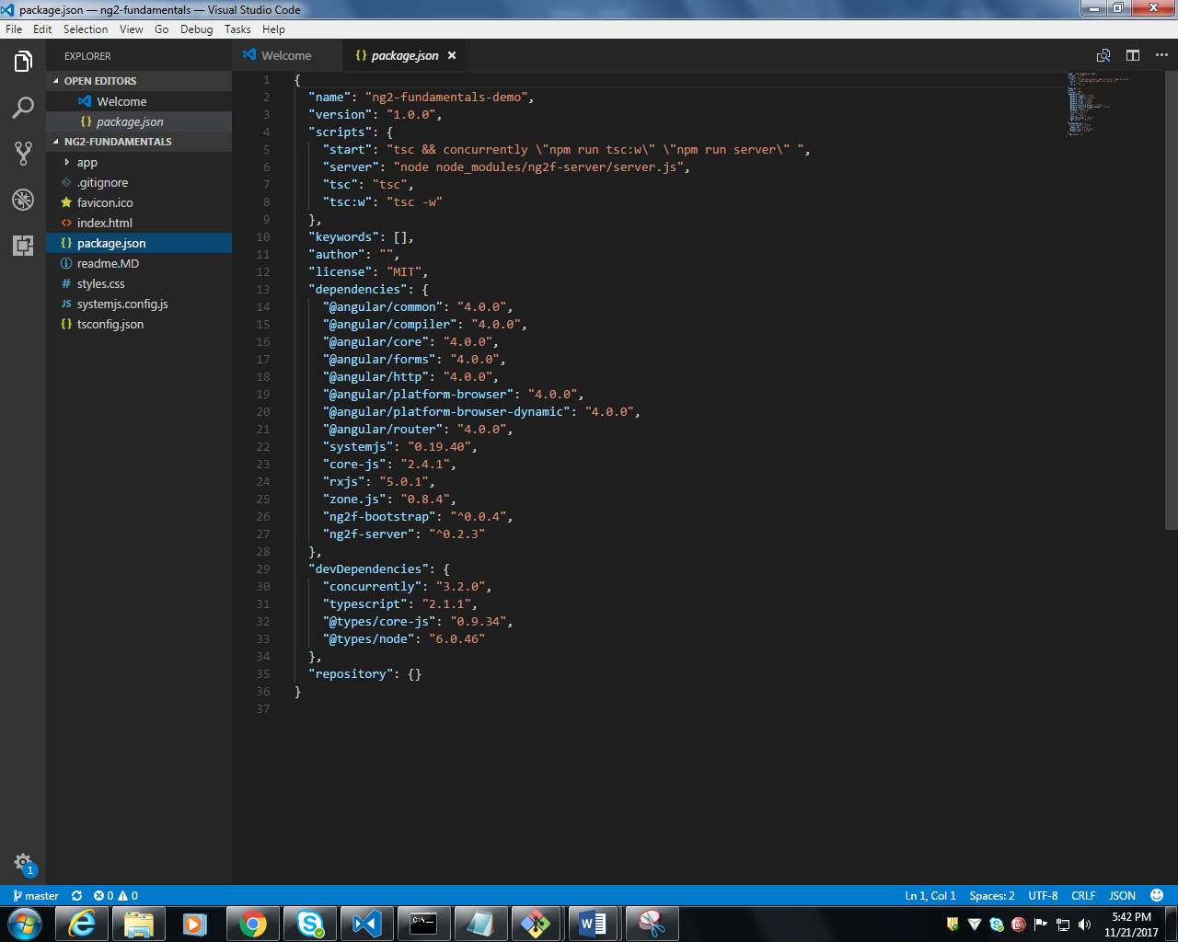

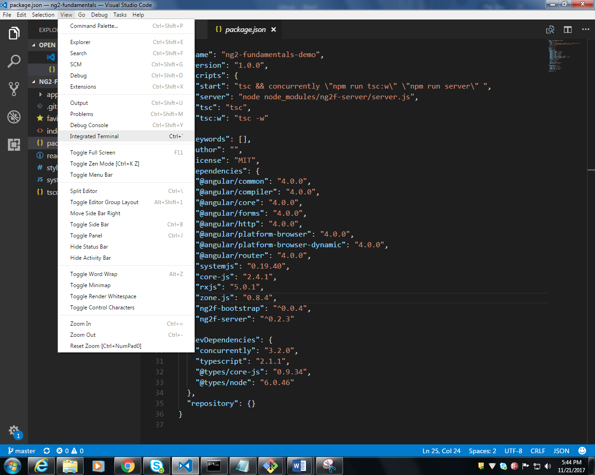

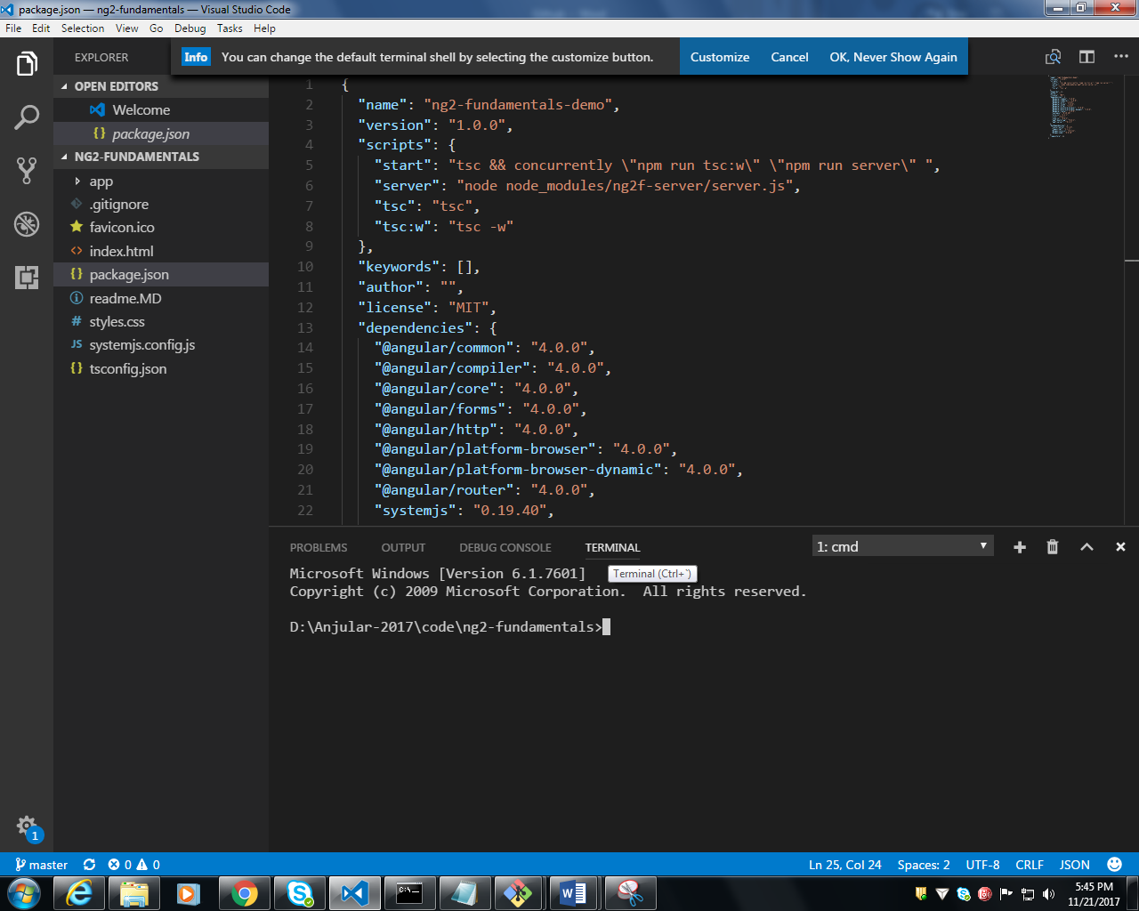

**NPM INSTALL**

**npm install**

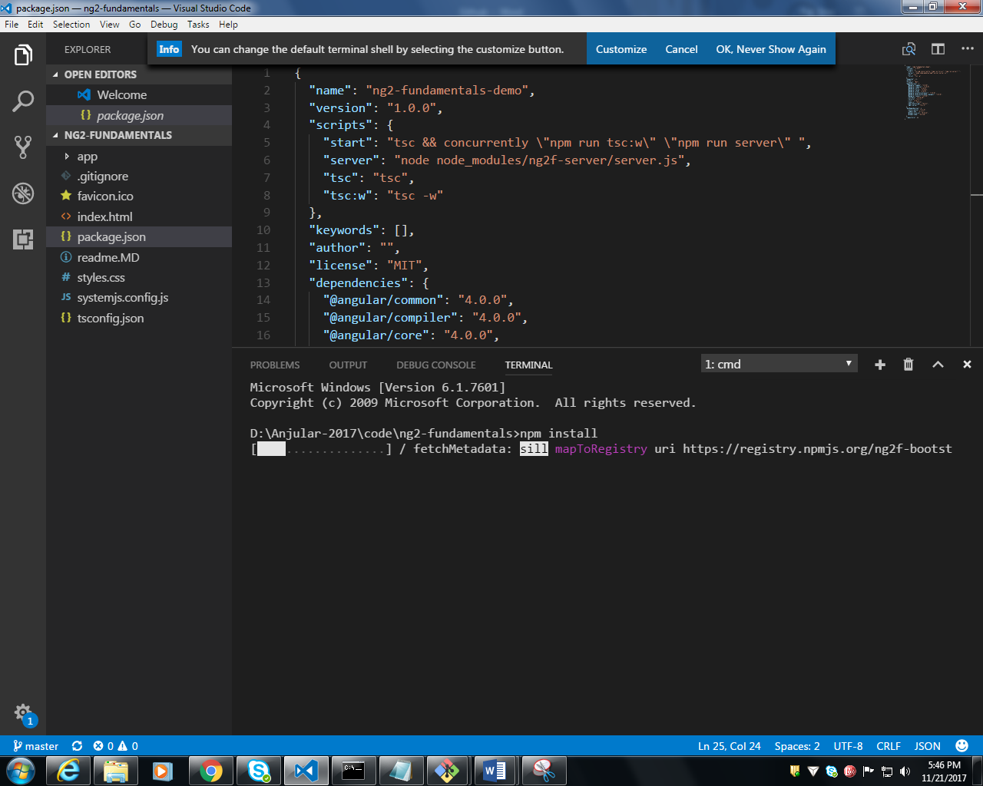

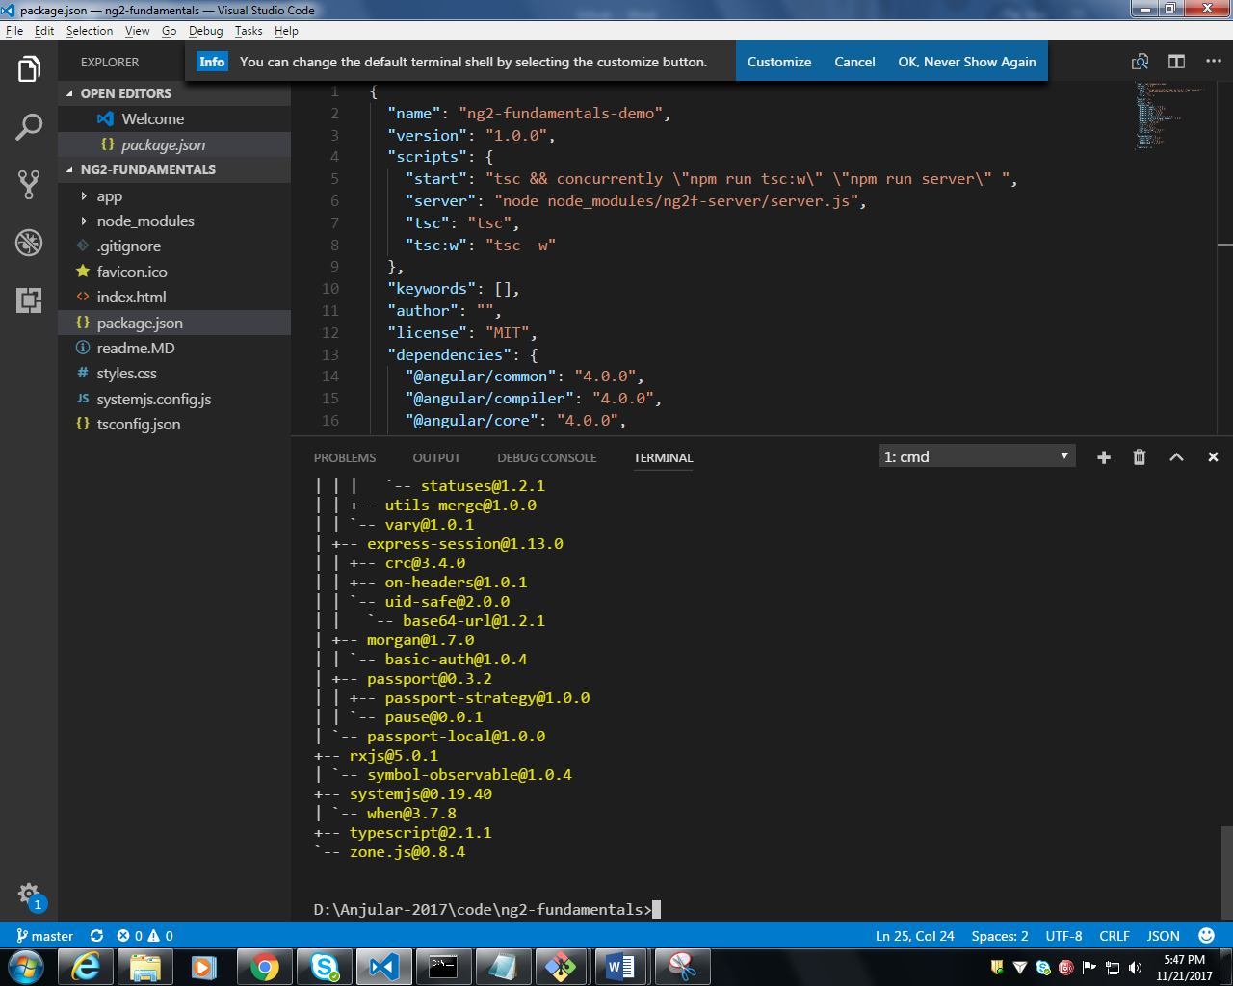

**All lib will be included inside node_modules folder**

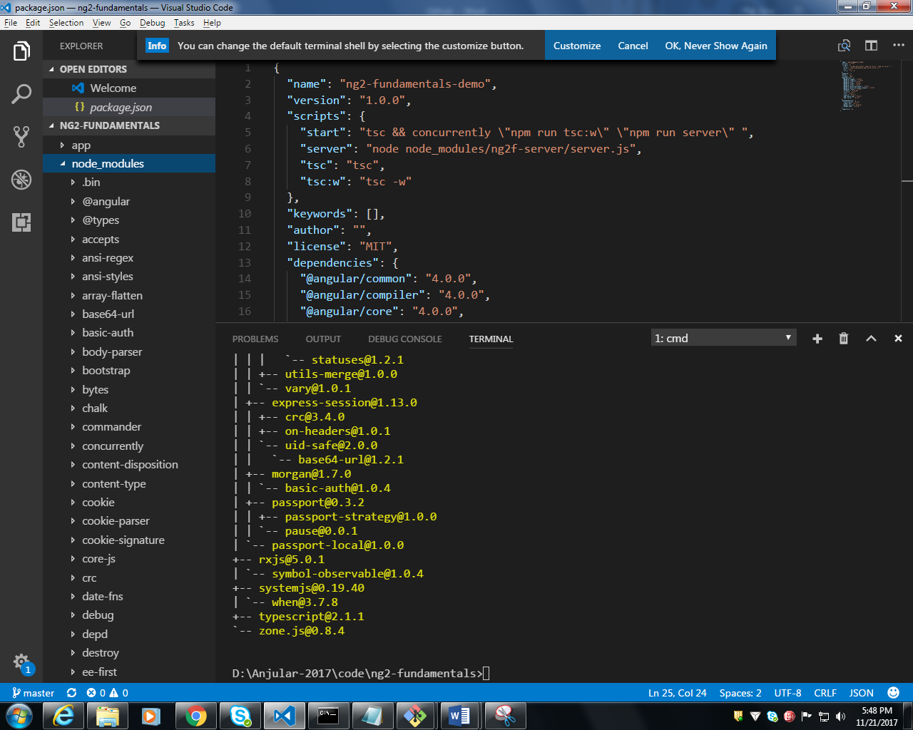

**Type npm start in terminal VSC**

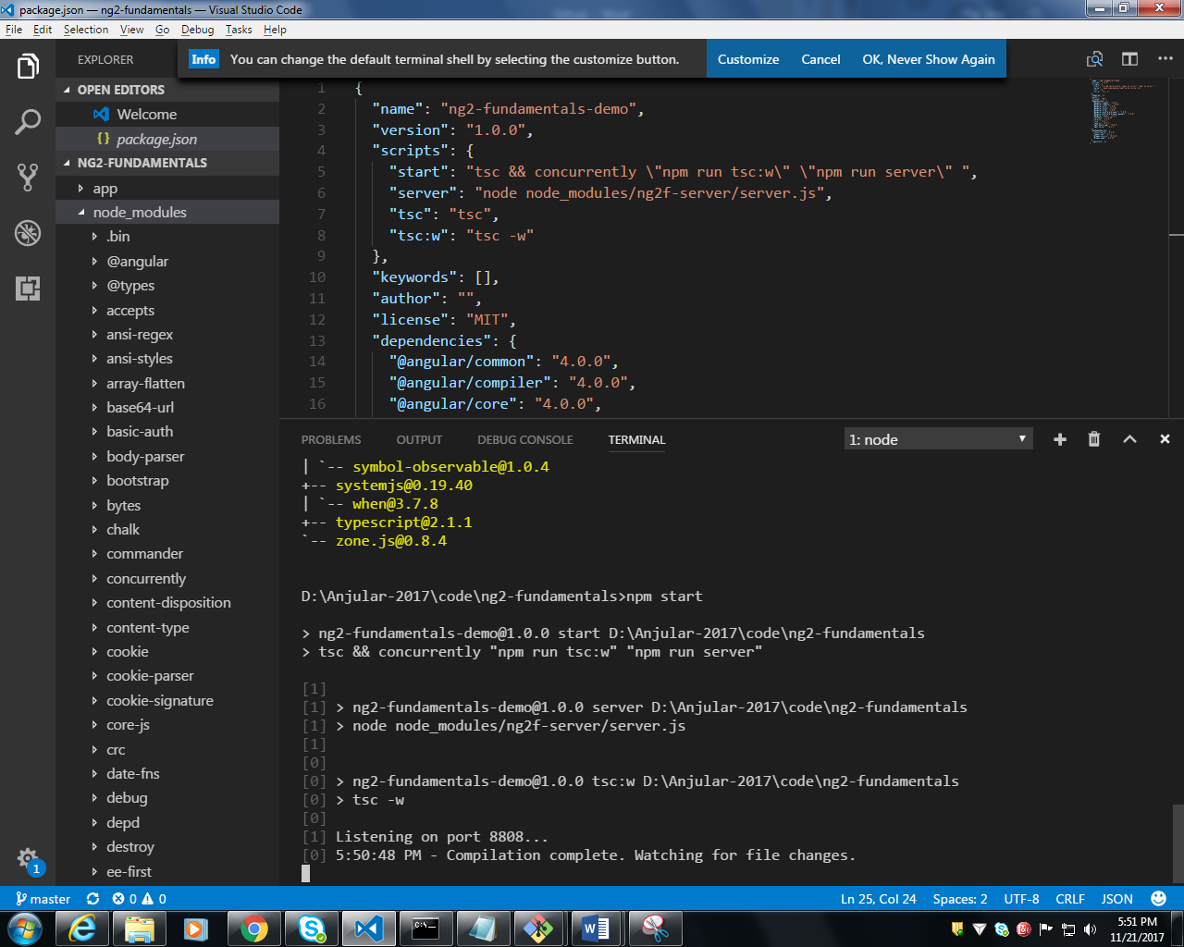

**Hit** <http://localhost:8808/> **in your browser.**

